

A Level Computer Science Project

[Document subtitle]



June 18, 2018

Sam Macdonald

Mildenhall College Academy Sixth Form

Contents

Analysis - 1 -

What is the problem? - 1 -

Computational Methods - 1 -

Stakeholders - 2 -

Resaerch - 2 -

Appropriate features to incorporate into the solution Error! Bookmark not defined.

Features of the computational solution - 4 -

Limitations - 4 -

Requirements - 4 -

Success Criteria - 5 -

# **Analysis**

## What is the problem?

Describe what the problem is, the cause of the problem, and how it will benefit the client from any other program

After having an interview with my client and getting the requirements, the problem they have is relatively straight forward to solve. My client works for a company who deals with border control, surveying maritime routes for search and rescue as well as illegal activity. Currently, my client uses a notepad and pen to manually record the variables of the flight during each mission. This is not very efficient or useful because the data cannot be manipulated to produce reports or statistical modelling, for example. As the data is input manually, there is no validation so there can also be a lack of data consistency or integrity. As well as being time consuming, my client may have to search through the data manually. Due to human error, the client also makes mistakes and crosses out information, making it hard to read and understand what data there is when reviewing at a later date.

This current manual input of data, from the notepad and then into a computer is laborious and repetitive. This can be made redundant because the problem I will be trying to solve will allow the user to directly input the variables live, therefore taking out the notepad stage along with the inherent issues associated with this method of recording.

## Why is a Computational approach the most amenable?

Describe and justify the features that make the problem solvable by computational methods, explaining why it is amenable to a computational approach. Describe a manual system is not good for this problem

This problem needs a computational approach to solve it, rather than a manual/human approach, because the program would need to store a lot of information; if there are, for arguments sake, 100 different records in the database, it would be difficult to search for a particular attribute because a hand-written database doesn’t give you the privilege of using queries to search through the database. Therefore, it is much more efficient to store the data in an electronic database. Having a hand-written database can be prone to human error, because each day (a record) will have similar data and can be very repetitive, allowing the user to make mistakes – a computational approach to the problem will allow the user to edit and change data if they ever make a mistake. The program also needs to import a KML and a computer is needed in order to do this – doing this manually would be virtually impossible. Having a computational approach gives my client more scope, allowing them to do more with the raw data. Furthermore, if the user enters a note in the timeline for 10:00, and then decides to add another note at 09:00, the program can rearrange the table timeline so it is in chronological order. This would be difficult to amend on a manual record requiring re-written data and poor use of time and resources. In addition to this, the problem I will be trying to solve will be high client-side, because it will have a GUI to visualise the form, KML, print layout etc. in a clear, easy-to-read format.

## Stakeholders

### Identified suitable stakeholders for the project and described them explaining how they will make use of the proposed solution and why it is appropriate to their needs.

Those interested in this program would include individuals, or companies who have the need to log their flight missions. This could be the military or aerial imagery sectors or border control agencies such as Frontex. My client, who is also my end user, is familiar with flight missions and the key terminology which would be required in this program (e.g. ETD, ETA, MSN, Eng On etc.)

My stakeholder(s) will have a major input on the program’s development giving me feedback at each stage and suggestions for improvement. They will also directly influence the specification points that the program must meet to be successful.

## 

## In addition to this, I will need to produce a prototype of the program that is on course with the development timeline, to meet the client’s needs and may require adaptation during the process. Regular contact with and feedback from the client will ensure the project remains on track or allows for changes, which would need to be controlled to allow adjustments to scope, timeline or budget to give enhanced functionality to the client. Because my end user is my only stakeholder, I will not need to worry about disagreements between stakeholders regarding their requirements or outcomes.

## 

## ReseArch

**First interview**

I need to arrange an interview with the client, finding out specifically what the problem is and how I, the programmer, can make a product for them. Because I cannot currently meet the client in person, I have emailed them a questionnaire, providing questions to get enough information as possible. Here is a screenshot of the questionnaire document:

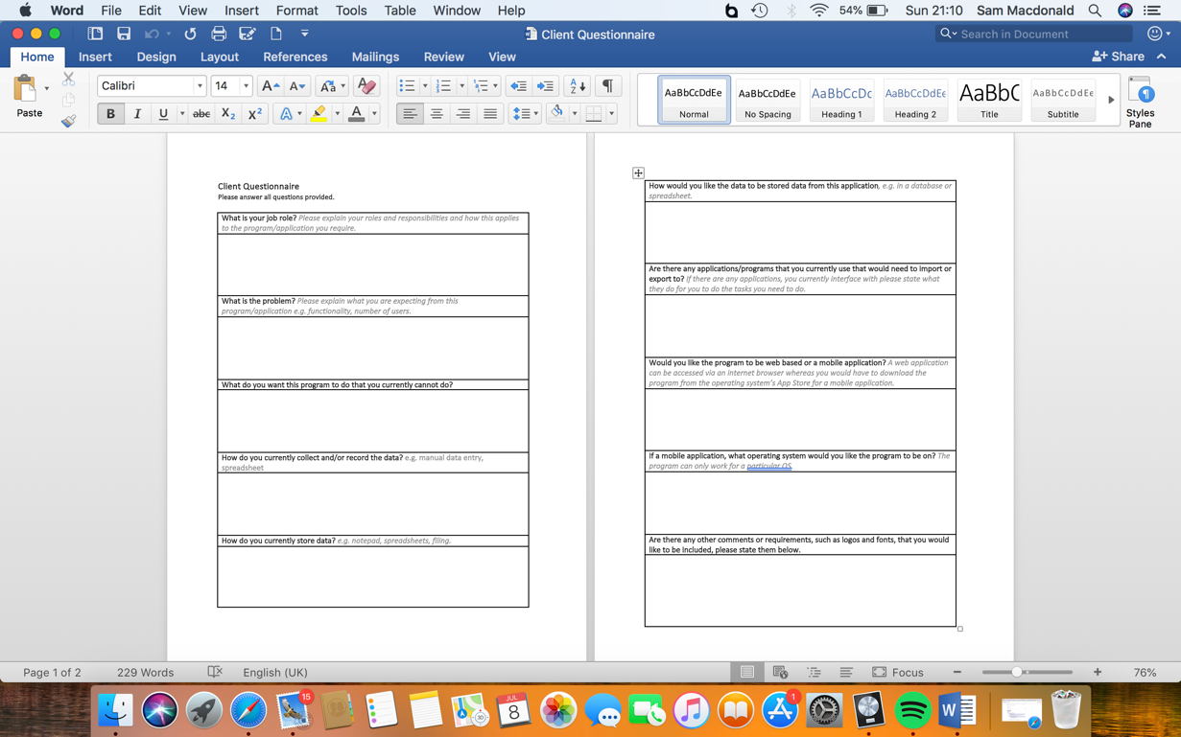

Here is a screenshot of the email I sent to the client:

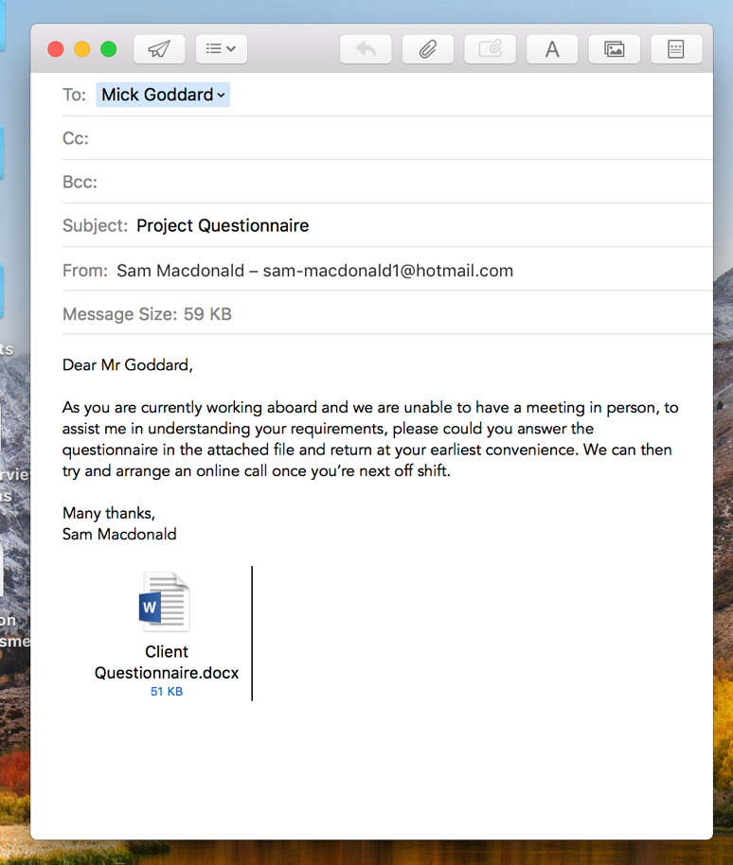

**Existing Products**

Adobe Acrobat is a family of application software, developed by Adobe, that allows the user to view, convert, edit, sign and print Portable Document Format (PDF). This application has some useful aspects for when the end users export a file as a PDF. As with all applications, there are some advantages and disadvantages. One advantage is that it is an Adobe product, meaning that it is legitimate software, providing conformity and reliability: Acrobat stores every detail (such as spacing, pictures and fonts) within the file itself, making it easier to share documents, if the provider has a font that the recipient has not got, the recipient doesn’t need to install the font. On the other hand, Adobe requires the user to pay for the full version of Acrobat: its £13.14 a month for the standard package or £15.17 a month for the pro package. However, Acrobat does offer a free version which has limited and restricted features.

Google Maps and OpenStreetMap are mapping software in which the user can view the world from the streets. This requires the internet however because it uses the uses GPS and the user’s location. An advantage of both applications is that it allows the user to import a KML (which is what the client wants out of my program.) However, some disadvantages of Google Maps and OpenStreetMap is the limited accuracy and the loss of privacy.

Excel is a spread-sheeting software, meaning that my client can create tables as well as importing a KML. Excel is a generic, easy to use, application that my client can use already. However, using a table or database in excel is inefficient, inconsistent and unreliable (if there is the same attribute in multiple tables, and I update an attribute in one table, the other table wont update). On the other hand, with Excel, you can create graphs from the tables, so, for example, my client could draw graphs of the average mission time in a week.

* Log application

**Bibliography**

<http://smallbusiness.chron.com/advantages-disadvantages-using-acrobat-77144.html>

<https://acrobat.adobe.com/uk/en/acrobat/pricing.html?mv=search&sdid=1FJDDN6S&s_kwcid=AL!3085!3!193496851174!b!!g!!acrobat&ef_id=WzXswwAABKLQJVza:20180629082541:s>

<https://www.buzzfeed.com/nirdesh191/disadvantages-and-advantages-of-using-google-maps-2q8ao?utm_term=.sq2mDMPqP#.ra0JWbOlO>

**Second Interview**

## 

## Features of the computational solution

### Identified the essential features of the proposed computational solution explaining these choices.

The client requires some sort of software that allows data input electronically, giving the option to update information. They have approached me to make a program which logs a flight mission, imports a Keyhole Markup Language (KML), allows them to write a timeline of events during the mission, saves the inputs in a database and finally the facility to print in a table format as a PDF.

## Limitations

### Identified and explained with justification any limitations of the proposed solution.

Whilst I aim to provide exactly what my client wanted, there are several limitations affecting the development of the solution; one of which is that my client has a busy schedule working abroad of 4 weeks on and 2 weeks off. If I need to contact them for advice/questions or to arrange an interview, then I would have to wait until they are off shift remotely, or meet when they are back in the UK. This could potentially slow down the development of the solution.

Because the client requested a phone application, rather than a web application, the solution must be for a specific operating system. If my client wanted their program on iOS and in the near future changed over to Android, then the program would not be available to use, due to the type of operating system.

## Requirements

### Specified and justified the requirements for the solution including (as appropriate) any hardware and software requirements.

The client want a program that records the different variables related to a flight mission (such as: engine on, take off, ETD (estimated time of departure), working out the flight time, then saving the inputs into a database. My client can have the option to upload a KML (Keyhole Markup Language) which can then be placed over a Google Maps (or other geographical software). My client can then see all the different dates and can select one, displaying all the inputted data in a table format, the KML on a geographical system, such as google maps . There will be an option to input and view data in a timeline for each date where the client can a time and the event that took place: for example, at 10:00, an event happens during the mission. Another table would be needed for this – having time and events as the column headings. However, if the user then adds a note at 09:00, then this will go before the 10:00 note so I need to create a function that orders the timeline in a chronological order. The client can have the option to print the table of data, KML, and timeline as a PDF, having the table of data and KML on one side, and the timeline on the other. My client also wants the DEA (Diamond Executive Aviation) logo printed on the PDF so I’ll need to import that image somehow.

If my client decides to have a web based application, rather than a mobile application, then the language I will use is PHP and HTML, whereas if my client uses a mobile application then I can either use Java or Python, and use their database application – JBDC for Java and SQLite for Python.

## Success Criteria

### Identified and justified measurable success criteria for the proposed solution.

For my program to be successful, it must meet all the requirements above. To find out if all the requirements are met, I will produce a questionnaire to give to the client, after the development and testing stage. Their response will tell me if the program has met the needs and satisfaction, if any improvements/maintenance are needed, giving me an indication on how successful the program is.

Does the program…

* Load up with no faults?
* Allow the user to create a new mission?
* Allow the user to enter data into the text fields?
* Allow the user to submit the data?
* Allow the user to view all the dates and information?
* Allow the user to add a timeline?
* Allow the user to import a KML?
* Allow the user to export as a PDF?
* Meet your satisfaction?

Is the program…

* Clear and easy to use?
* Fast to load data?

These criteria will be qu